

TOSHKENT SHAHRIDAGI INHA UNIVERSITETI

INHA UNIVERSITY IN TASHKENT

INTERNET PROGRAMMING

RESTAURANT

GROUP PROJECT



**Team Members:**

* Makhamadaliev Ibrokhimjon (U1810048) – section 004
* Rajabov Javokhir (U1810075) – section 003
* Akhmedov Fazliddin (U1810087) – section 003
* Kuziboev Anvar (U1810269) – section 003

**Link to Our GitHub repo: https://github.com/iuthub/ip-group-project-founders**

**Link to Our Web Site: http://protected-lake-57391.herokuapp.com**

## Project Overview

### Brief description of business and roles

### Functionality of website and its construction

### Contributions

**Brief description of website and its construction**

Benefits for costumers of website

They can reserve a table any time

* They can know cost of foods beforehand
* They can reserve a table any time
* They will not waste their valuable time on waiting dispatch to answer
* They will know what to expect from menu of restaurant

Benefits for restaurant of website Controlling and monitoring business

* Brand recognition
* Controlling and monitoring business
* Automation of a busines
* Growth of client base

**Functionality of website and its workflow construction**

**Home page**

**Home is the same for costumer and admin too.**

**In beginning of the home page, there are 3 carousel pages.**

**In the 1st one, clicked “More About Us” button goes to About page.**

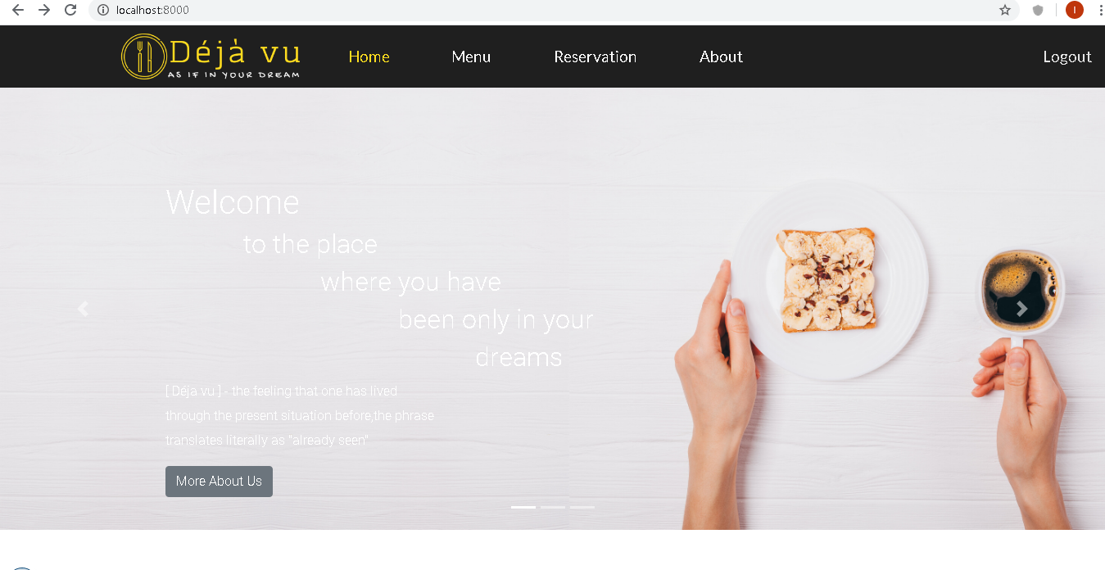

**In the 2nd one, clicked “Try It Now” leads to Menu page**

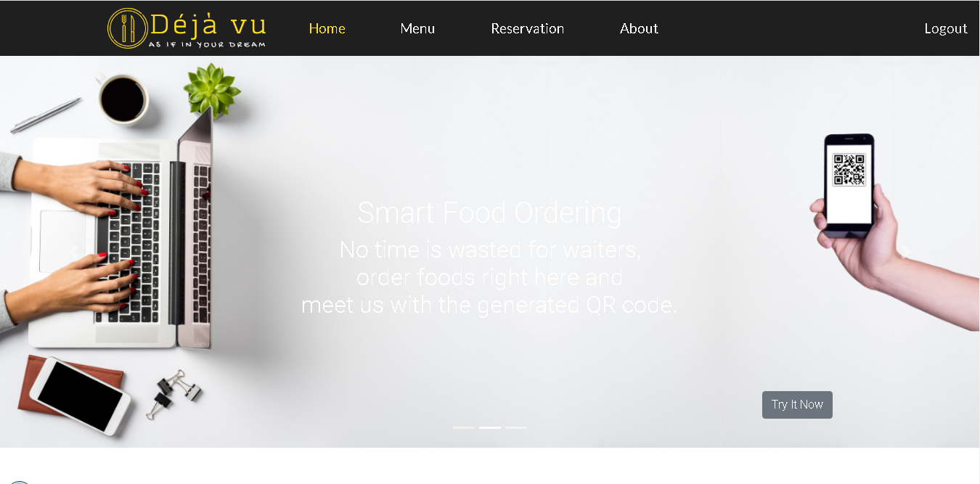

**In the 3rd one, clicked “ Sign Up Now” brings to the Register page.**

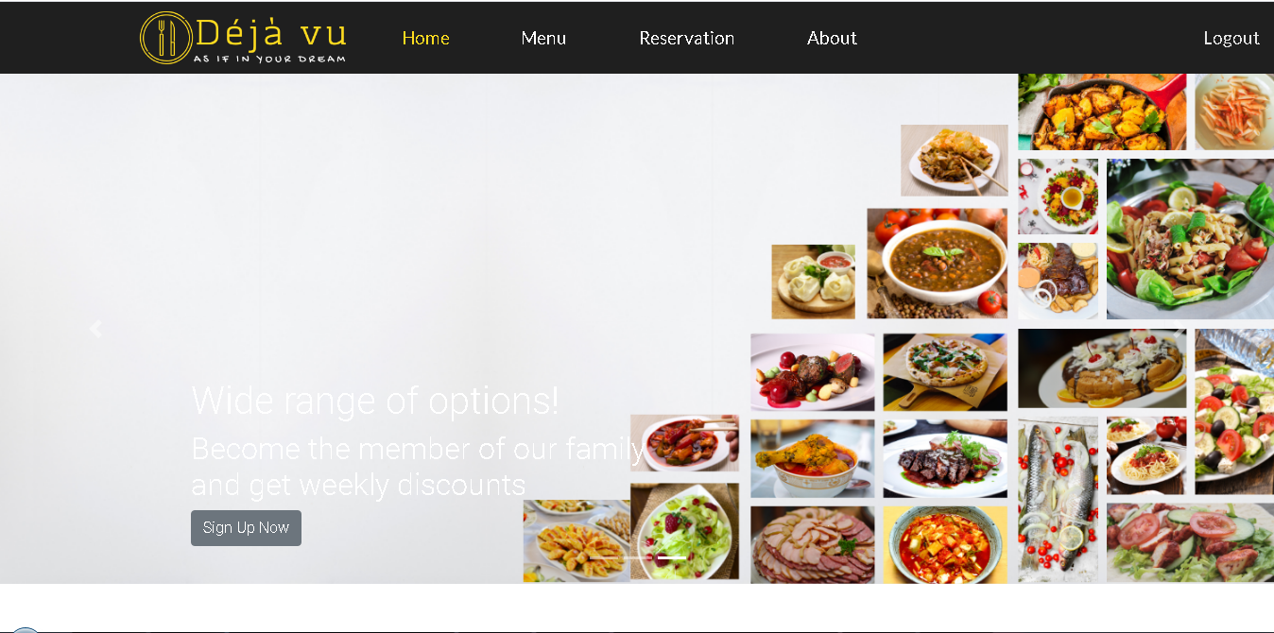

**And after that, weekly and monthly top 5 meals come.**

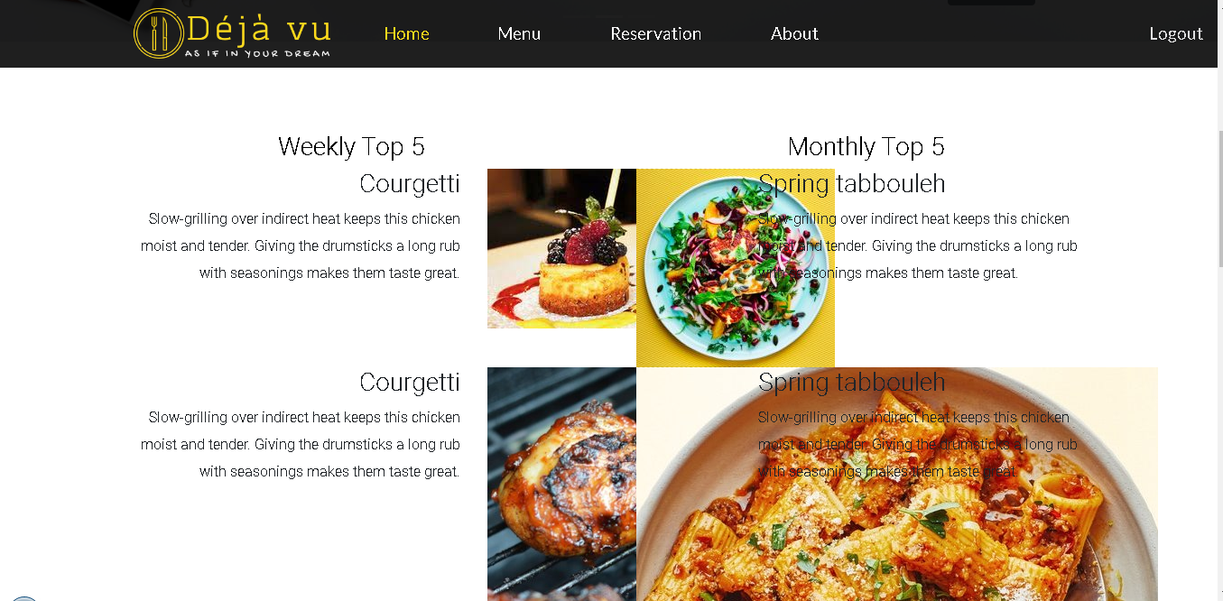

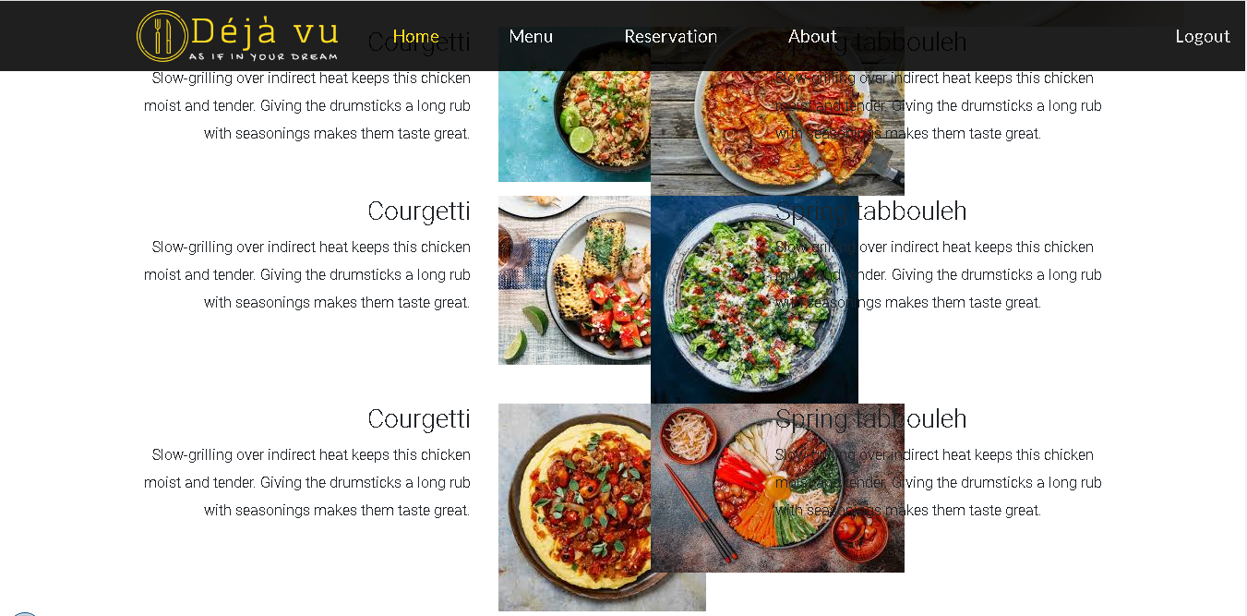

**And at the end of home page, there is a section for foods that are on discounts.**

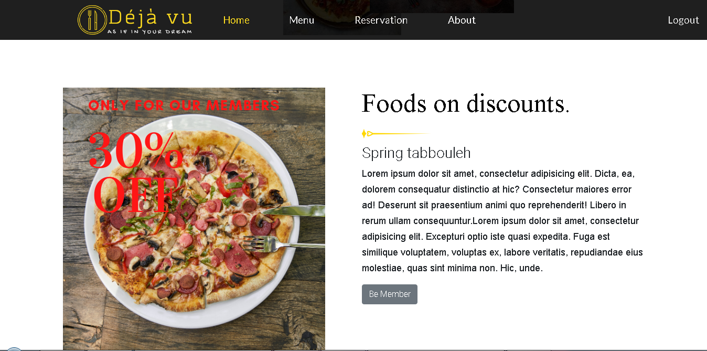

**Menu page**

**In the Menu pages, there are 2 pages. One is default and 2nd is for admin. For admin page, it needs to be logged as an admin.**

**Here are screenshots of admin where foods can be added, edited and deleted.**

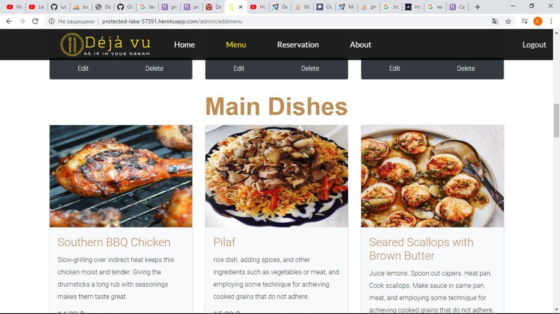

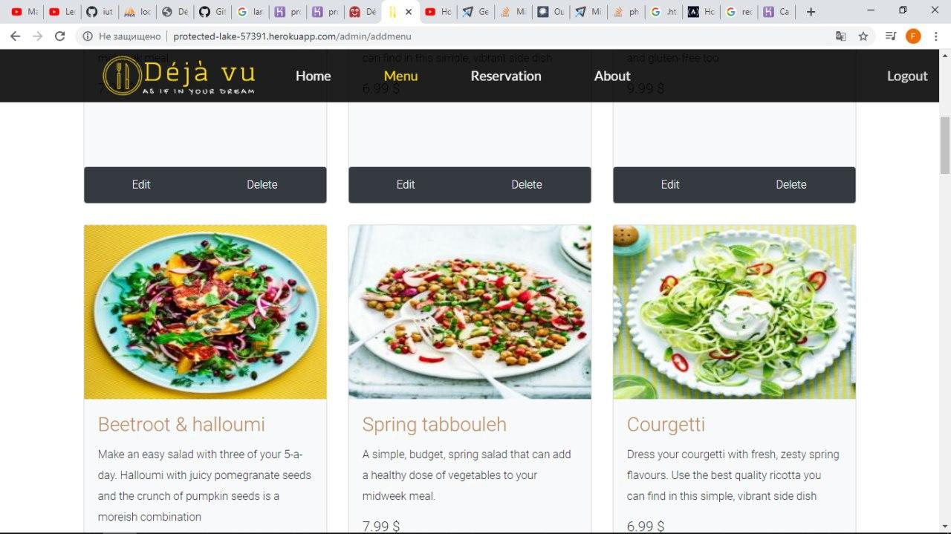

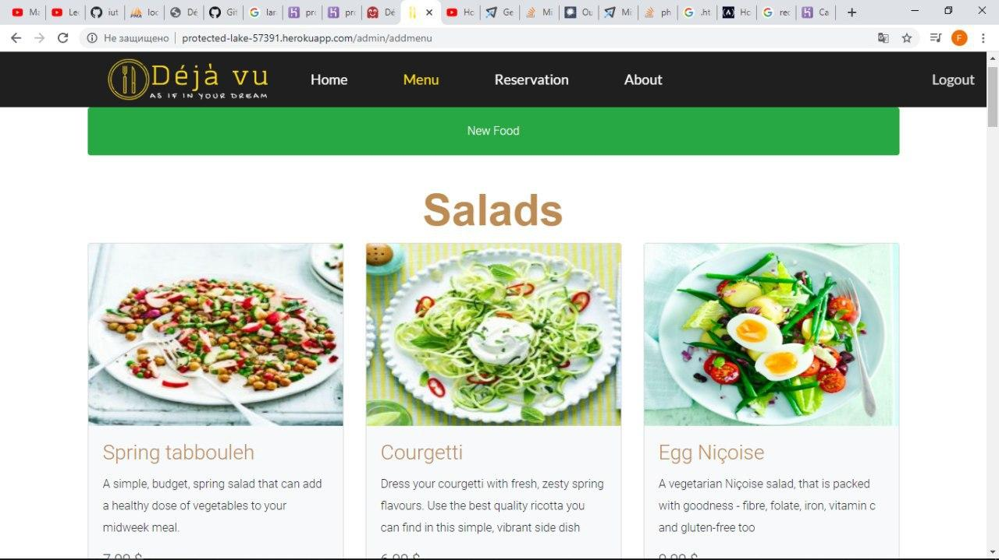

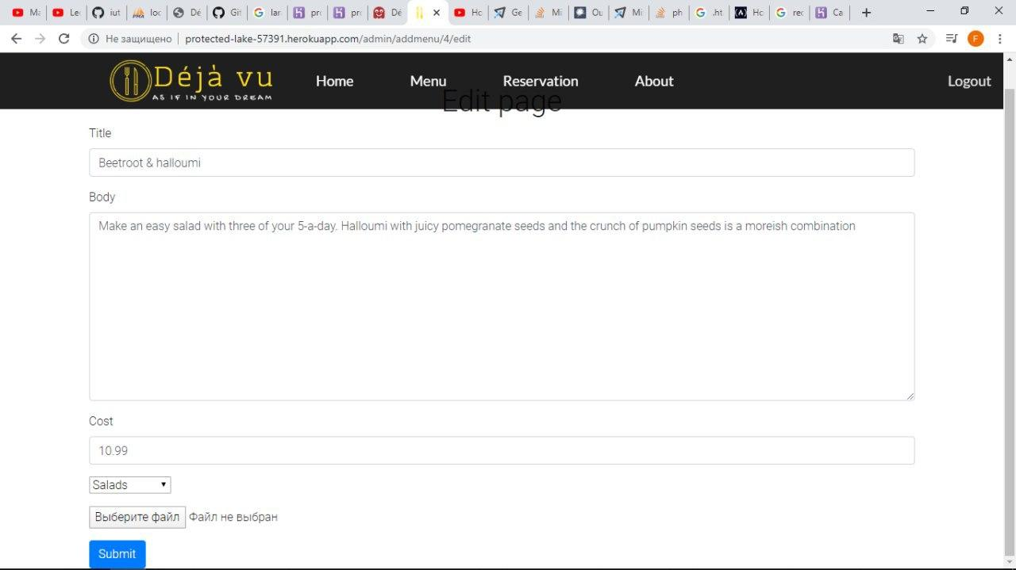

**And here Menu page for custumers.**

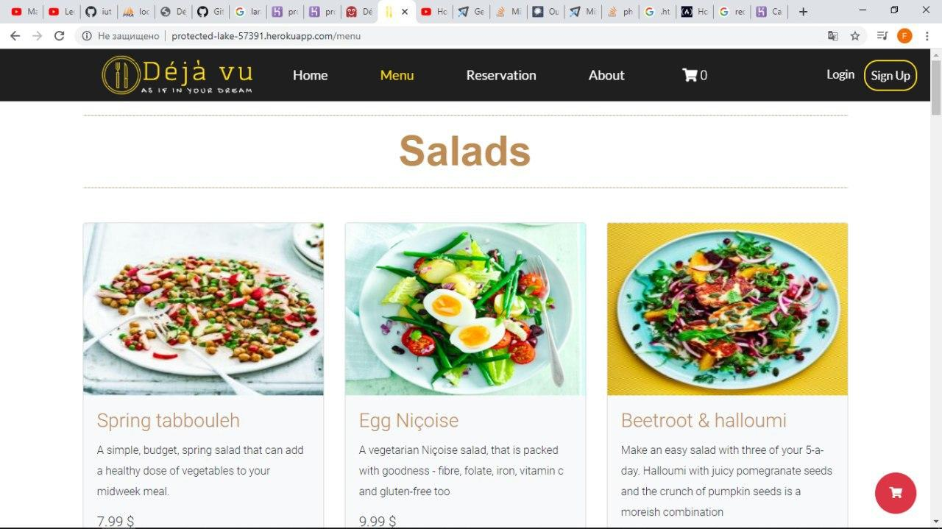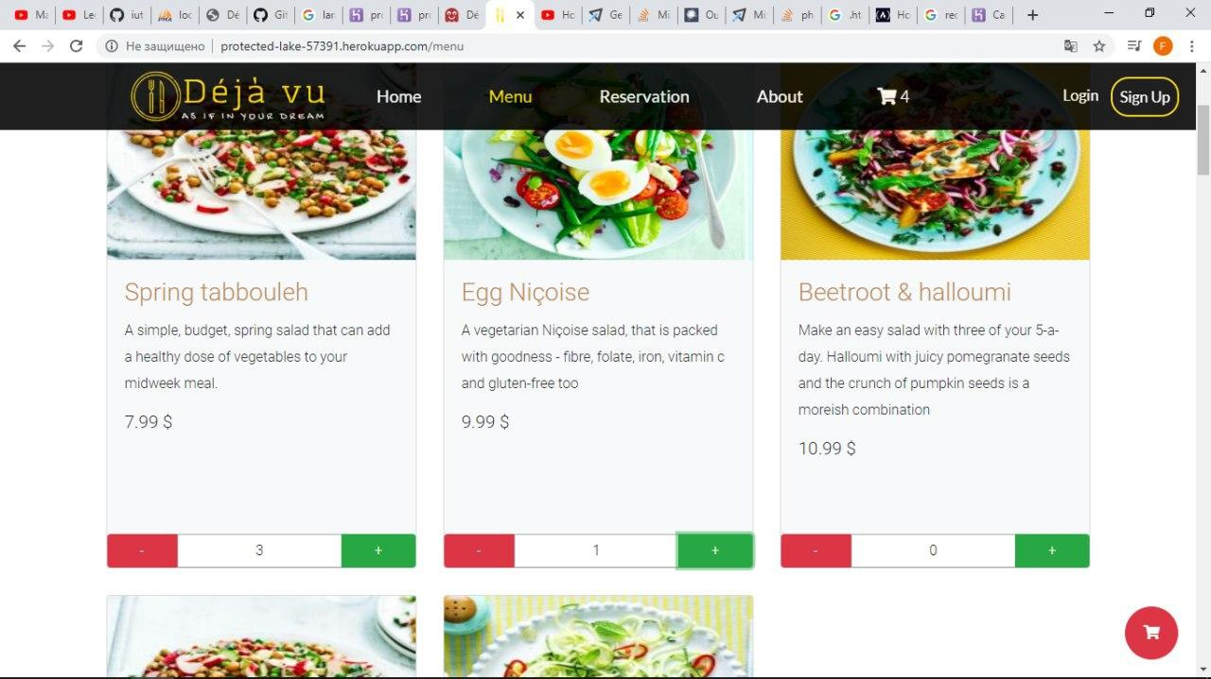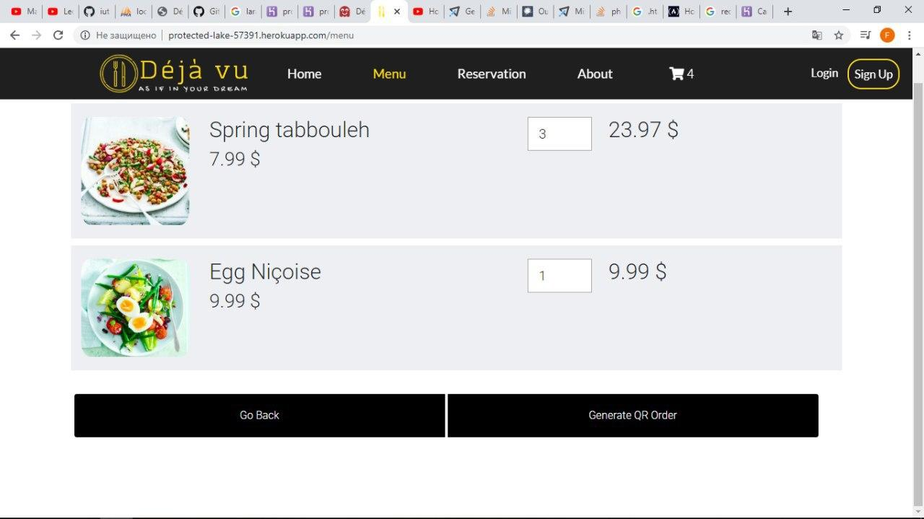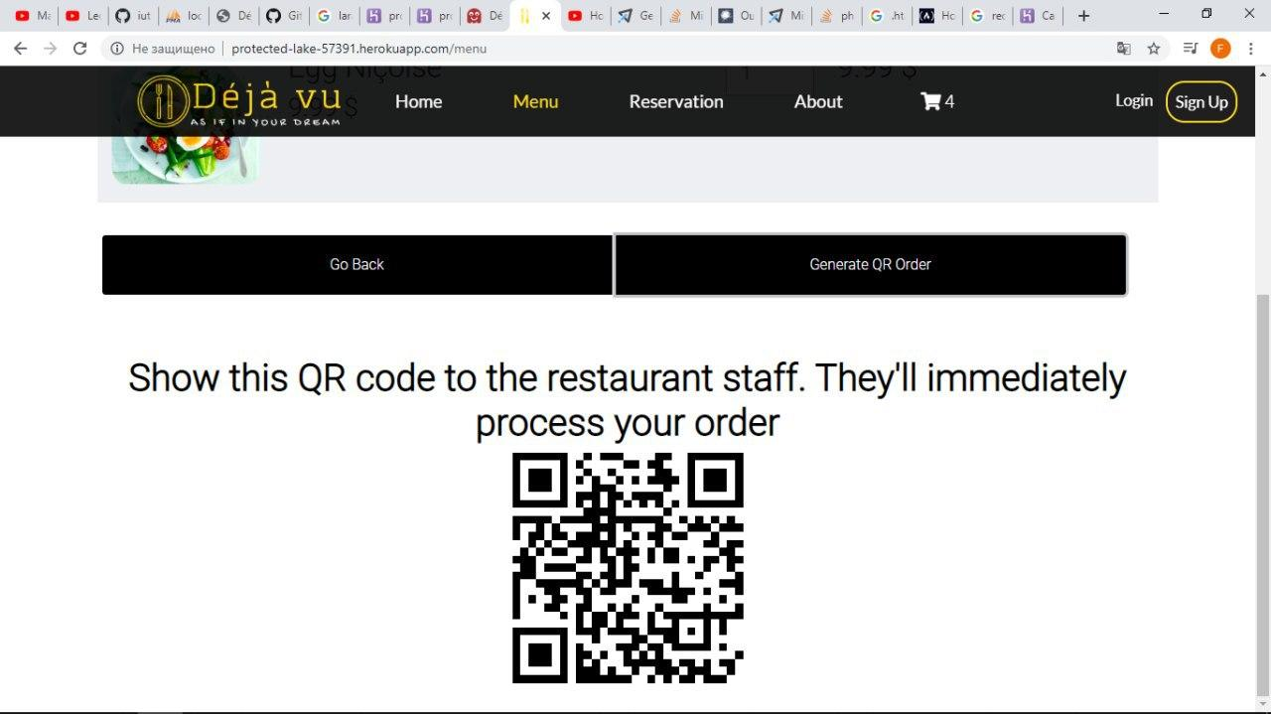

**About page**

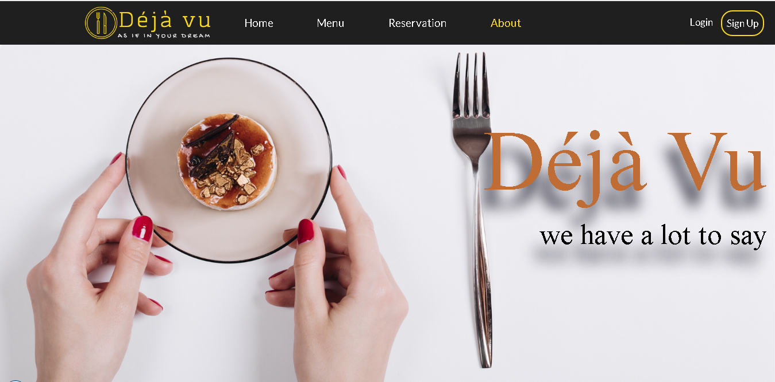

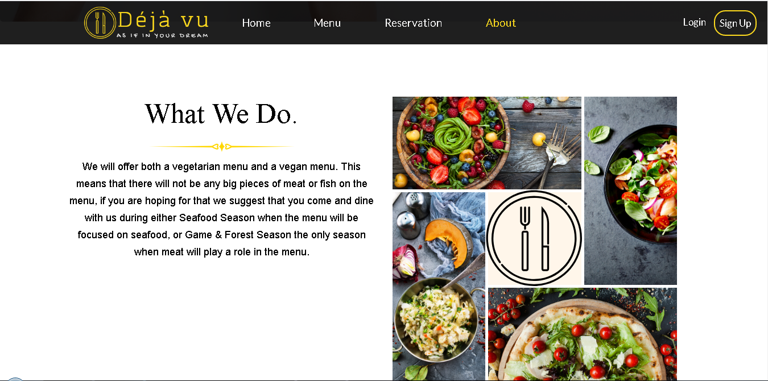

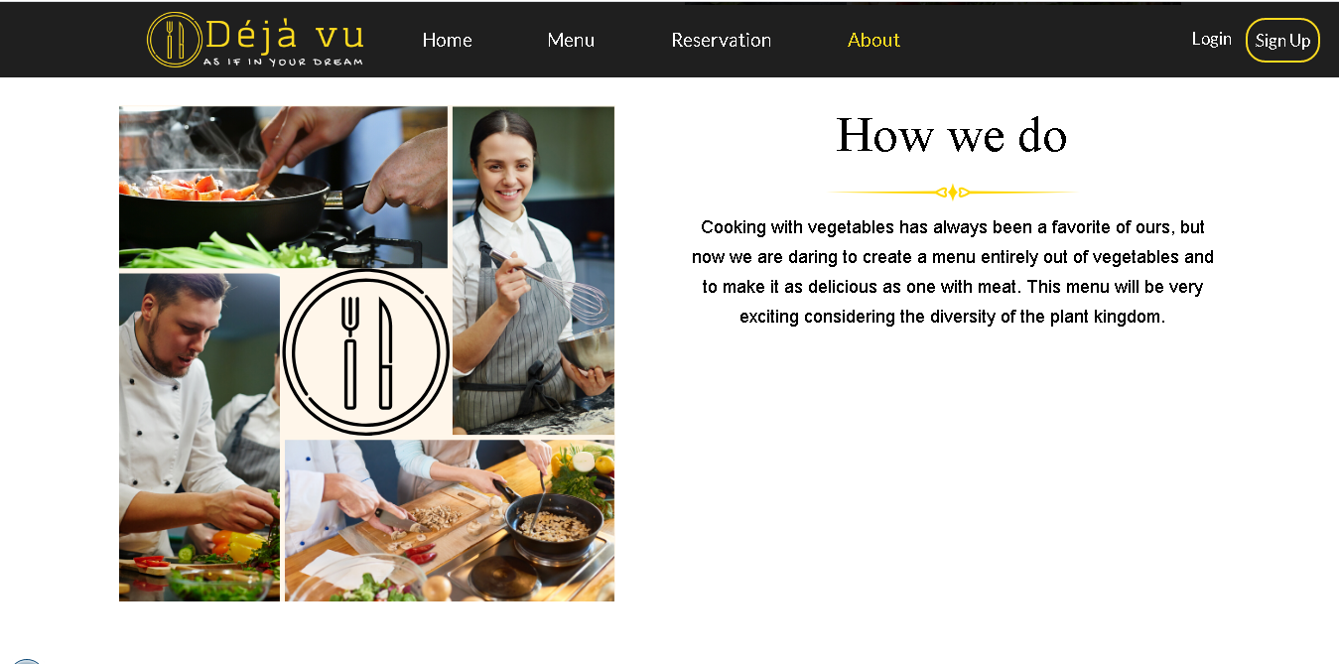

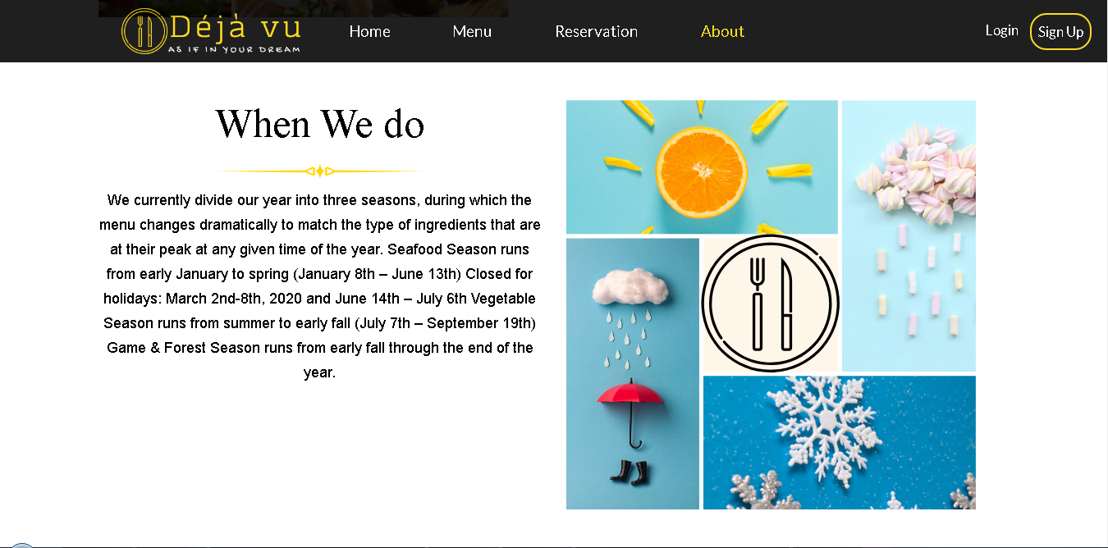

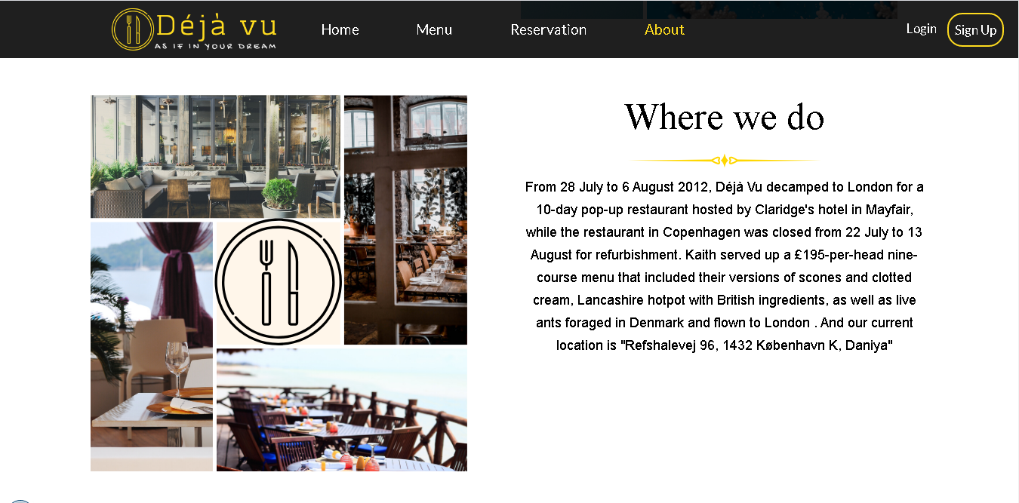



**Login Page**

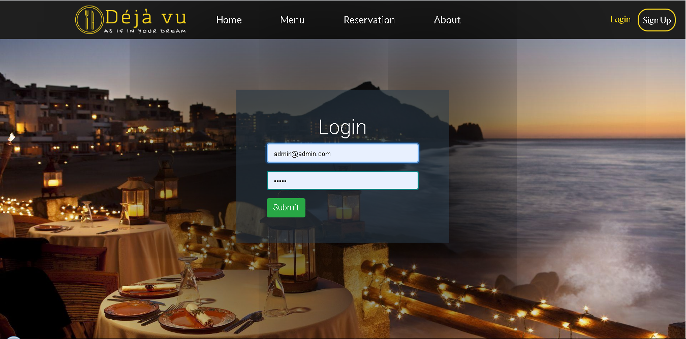

**Sign Up page**

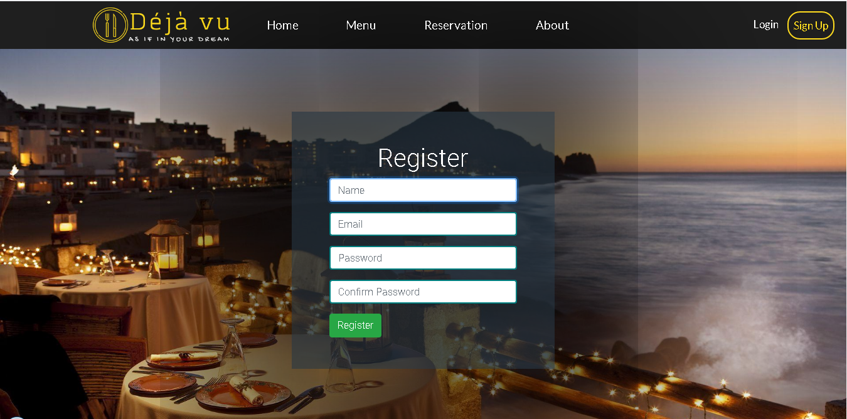

## Contributions

We have shared tasks as written below:

1. Makhamadaliev Ibrokhimjon- Partly Menu and Home page. Report of the Project
2. Rajabov Javokhir - Admin-side Back-end
3. Akhmedov Fazliddin – Front-end and Javascript functionality of menu page for admins and guests, backend of reservation, admin page of admin
4. Kuziboev Anvar – Front-end of login and singup and reservation